Major Adverse Cardiac Events while on statins– Phenotype Definition

Phenotype Description: Patients with Major Adverse Cardiac Events (MACE) while on statins. The type of MACE will be divided into revascularization events (bypass surgery or angioplasty/intracardiac stenting) and acute myocardial infarction (AMI). Additionally, patients will be distinguished as being their first event (e.g., the first MI) or not.

For either type of MACE (revascularization or AMI), the algorithm identifies two cohorts based on the data from electronic medical records (EMRs). One is the group of subjects of the MACE (revascularization or AMI) while on statin, and the other is the group of subjects of 1st MACE while on statin. The latter is a subset of the former.
If you have questions regarding any of the information presented on this page, you may contact either:
Wei-Qi Wei at wei-qi.wei@vanderbilt.edu
Joshua Denny at josh.denny@vanderbilt.edu

Algorithms for the Phenotype

AMI on statin | - At least 2 current AMI Codes (410.* or 411.*) within a 5-Days Window  - Confirmed Lab within the same time window defined by  - Troponin-I≥0.10 ng/ml  - or Troponin-T≥0.10 ng/ml,  - or CK-MB/CK ratio≥3.0 and CK-MB ≥10.0 ng/mL  - Statin prescribed prior to the AMI event ≥180 days
1st AMI on statin | - AMI on statin  - No any AMI codes (410.*, 411.*, or 412.*) assigned before the AMI event  - No AMI mentioned in previous problem list by NLP
Revascularization while on statin | - Any CPT code for angioplasty or stent (see below)  - statin prescribed prior to the procedure ≥180 days
1st Revascularization  while on statin | - Revascularization while on statin  - No exclusion codes before starting statin (see below)  - No revascularization mentioned in previous problem list by NLP
Statin exposure | - The number of days that the earliest statin prescription prior to the event (AMI/Revascularization)
All-cause mortality | - EMR or social security death index (SSDI) defined mortality (date)

The timeline of AMI on statin
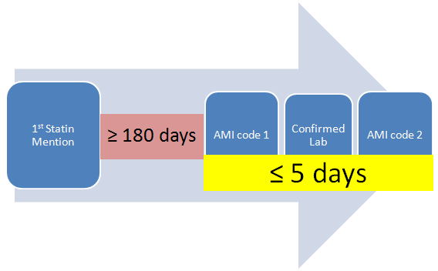
AMI on statins: Case definition (all three conditions required):
- At least two ICD9 code for AMI or other acute and subacute forms of ischemic heart disease within a five-day window (see AMI Case ICD9 codes below)
- Confirmed lab within the same time window (see AMI Case lab names/values below)
- Statin prescribed prior to the AMI event in medical records at least 180 days

The timeline of 1st AMI on statin

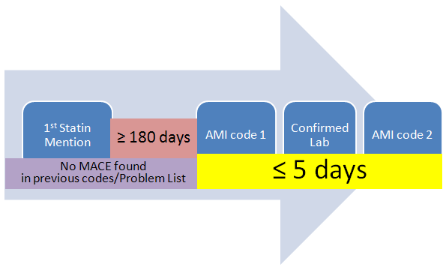

1st AMI on statins: Case definition (all four conditions required):
- Meet the above criteria for AMI on statins
- No diagnosis code for AMI, other acute and subacute forms of ischemic heart , or historical AMI assigned previously (see Case exclusion ICD 9 codes below)
- No revascularization CPT codes assigned previously (see Revascularization CPT codes below)
- No MACE found in previous problem list by NLP (see MACE Exclusion keywords listed below)
Revascularization while on statin: Case definition (both conditions required):
- At least one revascularization CPT code (see Revascularization CPT codes below)
- Statin prescribed prior to the revascularization event in medical records at least 180 days

1st Revascularization while on statin: Case definition (all four conditions required):
- Meet the above criteria for revascularization while on statin
- No diagnosis code for AMI, other acute and subacute forms of ischemic heart , or historical AMI assigned previously (see Case exclusion ICD 9 codes below)
- No revascularization CPT codes assigned previously (see Revascularization CPT codes below)
- No MACE found in previous problem list by NLP (see MACE Exclusion keywords listed below)

Control definition
- Statin prescribed
- No diagnosis code for AMI, other acute and subacute forms of ischemic heart , or historical AMI assigned previously (see Case exclusion ICD 9 codes below)
- No revascularization CPT codes assigned previously (see Revascularization CPT codes below)
- No MACE found in previous problem list by NLP (see MACE Exclusion keywords listed below)

Variables of Interest

Medication keyword list

Simvastatin, Zocor
Fluvastatin, Lescol, Canef, Vastin
Atorvastatin, Lipitor
Pravastatin, Pravachol, Selektine
Lovastatin, Mevacor
Cerivastatin, Baycol, Lipobay
Rosuvastatin, Crestor

AMI Case ICD9
410.*: AMI
411.*: Other acute and subacute forms of ischemic heart disease

AMI Case lab names/values
TnI: >=0.10 ng/ml
TnT: >=0.10 ng/ml
CKMB ratio: >=3.0 and CK-MB >=10.0 ng/mL

Case exclusion ICD 9 codes
410.*: AMI
411.*: Other acute and subacute forms of ischemic heart disease
412: Old myocardial infarction

Revascularization CPT codes
CABG
33533 – coronary artery bypass, using arterial grafts; single arterial graft
33534 - coronary artery bypass, using arterial grafts; two coronary artery grafts
33535 - coronary artery bypass, using arterial grafts; three coronary artery grafts
33536 - coronary artery bypass, using arterial grafts; four or more coronary artery grafts
33510 - coronary artery bypass, vein only, single coronary venous graft
33511- coronary artery bypass, vein only, two coronary venous grafts
33512- coronary artery bypass, vein only, three coronary venous grafts
33513- coronary artery bypass, vein only, four coronary venous grafts
33514- coronary artery bypass, vein only, five coronary venous grafts
33515- coronary artery bypass (old code)
33516- coronary artery bypass, vein only, six coronary venous grafts
33517 - coronary artery bypass, using venous grafts and arterial grafts, single vein graft
33518 - coronary artery bypass, using venous grafts and arterial grafts, two venous grafts
33519- coronary artery bypass, using venous grafts and arterial grafts, three venous grafts
33520 - coronary artery bypass (old code)
33521 - coronary artery bypass, using venous grafts and arterial grafts, four venous grafts
33522 - coronary artery bypass, using venous grafts and arterial grafts, five venous grafts
33523 - coronary artery bypass, using venous grafts and arterial grafts, six venous grafts

PTCA
92980 – transcatheter placement of an intracoronary stent, percutaneous, with or without other therapeutic intervention, any method, single vessel
92981 - transcatheter placement of an intracoronary stent, percutaneous, with or without other therapeutic intervention, any method, each additional vessel
92982 – percutaneous transluminal coronary balloon angioplasty, single vessel
92984 – percutaneous transluminal coronary balloon angioplasty, each additional vessel
92995 - percutaneous transluminal coronary atherectomy, by mechanical or other method, with or without balloon angioplasty, single vessel
92996 - percutaneous transluminal coronary atherectomy, by mechanical or other method, with or without balloon angioplasty, each additional vessel
C1874 - Stent, Coated/Covered, With Delivery System
C1875 - Stent, Coated/Covered, Without Delivery System
C1876 - Stent, Non-coated/Non-covered With Delivery System
C1877 - Stent, Non-coated/Non-covered Without Delivery System

Case Keywords
AMI: “ AMI ”,“ MI ”,“acute myocardial infarction”, “myocardial infarction”
Revascularizaion: “CABG”, “coronary artery bypass”, “cypher”, “taxus”, “BMS”, “DES”, “stent”

MACE Exclusion keywords (if present, cannot be a control)
“ AMI ”,“ MI ”,“acute myocardial infarction”, “myocardial infarction”, “CABG”, “coronary artery bypass”,
“cypher”, “taxus”, “BMS”, “DES”, “stent”

