Preliminary Estimate of Potential Carotid Artery Atherosclerosis Disease (CAAD) Phenotype Cases
Based on the eMERGE Record Counter
Version 1
January 14, 2014
David Carrell and David Cronkite
Phenotype Definition
Carotid artery atherosclerosis disease (CAAD) is a narrowing or constriction of the inner surface of the carotid artery associated with increased risk for transient ischemic attack and thromboembolic stroke. CAAD is documented in the EMR by ICD codes (i.e., ICD: 433.1) and is measured quantitatively as a percent stenosis (narrowing) by Doppler ultrasound and related imaging studies (e.g., CPT: 93880). An exclusion criterion for the CAAD phenotype is hypercholesterolemia (ICD: 272.0). Hypercholesterolemia is the presence of high levels of cholesterol in the blood, which over long periods of time may result in arterial plaque, which can lead to stenosis or occlusion (blockage) of the involved arteries.
Preliminary Estimate
As a preliminary estimate of the prevalence of CAAD in the eMERGE network we used the eMERGE Record Counter (https://biovu.vanderbilt.edu/EmergeRC/) to identify subjects having one or more diagnosis codes for CAAD (ICD: 433.1*) and no diagnosis codes for a family history of hypercholesterolemia (ICD 272.0). While it is possible to qualify as a CAAD case without the presence of an ICD code (e.g., via documentation in clinical text of carotid stenosis, extracted by natural language processing), a diagnosis codes provide a useful rough estimate of potential CAAD cases. We estimate there are 2,147 CAAD cases network-wide. The distribution of potential CAAD cases by eMERGE site follows.
Table 1. Counts of potential CAAD cases by eMERGE site.
Site | Count
GHC/UW | 160
Geisinger | 354
Marshfield Clinic | 58
Mayo Clinic | 680
Mt. Sinai | 154
Northwestern University | 402
Vanderbilt University | 339
All Sites | 2147
Source: eMERGE Record Counter, 1/14/2014
Using Record Counter
In case this is useful to others who want to use the Record Counter for similar purposes, here is how we generated the above estimates:
- Log in to the the eMERGE Record Counter (https://biovu.vanderbilt.edu/EmergeRC/) using a PheKB username and password.
- On the Record Counter’s Search tab click on “Search Criteria.”
- In the “Search ICD and CPT code criteria” cell enter the ICD code “433.1” (for CAAD), then click Search.
- Expand the ICD node below the Search button to see qualifying codes, which will be:
  - 433.1
  - 433.10
  - 433.11
- Drag each of the ICD codes from the code list on the left to the “Include records where:” field on the right.
- Again, in the “Search ICD and CPT code criteria” cell, enter the ICD code “272.0” (for familial hypercholesterolemia), then click Search
- Expand the ICD node below the Search button to see the (one) qualifying code:
  - 272.0
- ICD 272.0 is an exclusion code, so you will need to open a new field on the right side of the screen for exclusions. Do this by clicking the “Add Group” button. When the new field appears, click the “Exclude Group” button on its right. The label above the new field will now display “AND Exclude records where:.”
- Drag the ICD code 272.0 from the code list on the left to the new field on the right.
- At this point the screen should look like the screenshot in Figure 1 below.
- Now save the query by clicking “Save Query” and giving it a name (e.g., “CAAD excluding familial hypercholesterolemia”). Once saved, you can view the query’s results by clicking the Results tab.
- In the results tab, click the “All Sites” tab in the lower right pane to display counts by site of subjects satisfying the saved query. The screen should look like the screenshot in Figure 2 below.
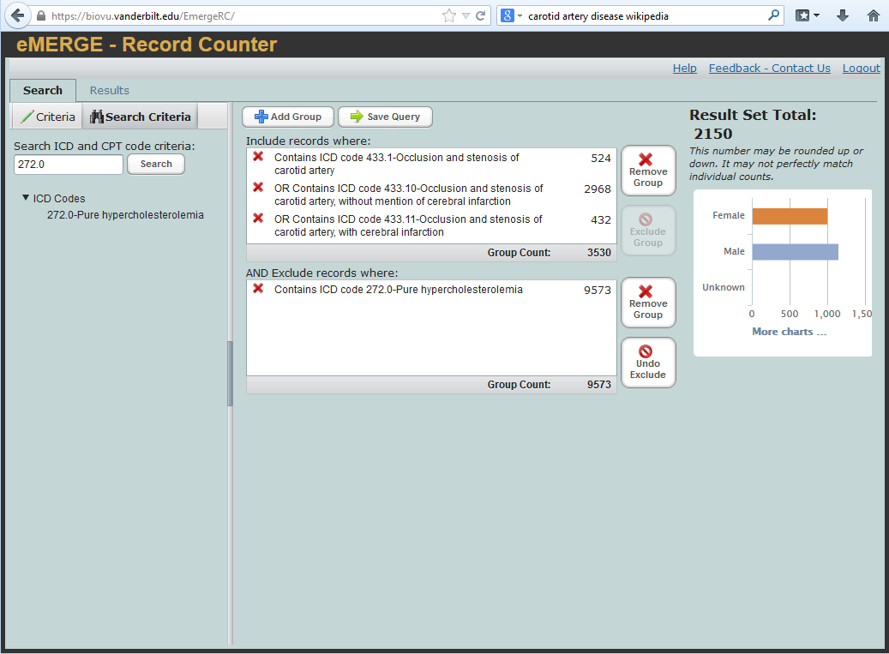
Figure 1. Record Counter display of search criteria for the CAAD phenotype preliminary estimate.
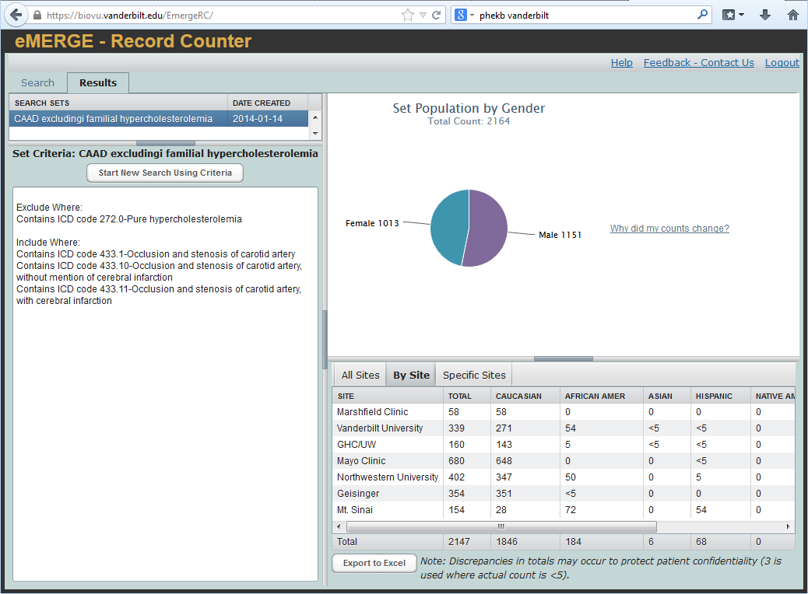
Figure 2. Record Counter display of query results by site for the CAAD phenotype preliminary estimate.

