Migraine
Migraine is the most common recurrent headache syndrome in children in which 4-10% of school age children may be affected (1). It is characterized by episodes of headache pain that may be accompanied by nausea, vomiting, and light and sound sensitivity. Migraine occurs at all ages and may even begin in infancy as represented by intermittent colic (1). The genes for familial hemiplegic migraine have been identified. For migraine without aura and migraine with aura population and twin studies have been consistent with the genetic basis of migraine, but no consistent genetic etiology has been established. Both genetic and environmental factors are important (2). The International Classification of Headache Disorders 3rd edition (ICHD-3) is the current gold standard for the diagnosis of migraine, especially for research purposes. ICHD-3 notes that certain features of migraine in children may differ from typical features in adults for example it is often bilateral in children, and unilateral pain usually emerges in late adolescence or early adulthood and childhood migraines may be shorter in duration. ICHD-3 criteria require at least five attacks to fulfill the diagnosis of migraine.
Diagnostic Criteria for Migraine
Please note, the flowchart below is intended to illustrate the flow of the algorithm, which includes all 4 case types (Hemiplegic, Aura, Without Aura, and Unclassified Migraine). Case labels (numeric) are indicated in the data dictionary.
Use Flowchart below to start between Hemiplegic and other kinds of migraine.
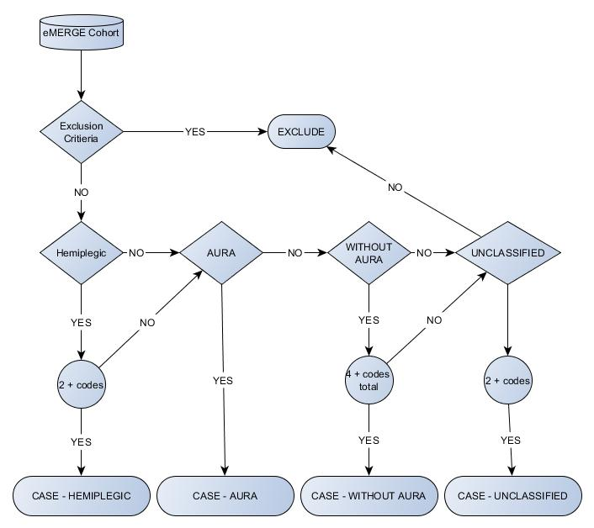
Migraine without aura
A. At least five attacks fulfilling criteria B through D
B. Headache attacks lasting 4 to 72 hours (untreated or unsuccessfully treated. 2-72 hours in children under 18)
C. Headache has at least two of the following characteristics:
- Unilateral location
- Pulsating quality
- Moderate or severe pain intensity
- Aggravation by or causing avoidance of routine physical activity (eg, walking or climbing stairs)
D. During headache at least one of the following:
- Nausea, vomiting, or both
- Photophobia and phonophobia
Migraine with aura
A. At least two attacks fulfilling criterion B and C
B. One or more of the following fully reversible aura symptoms:
- Visual
- Sensory
- Speech and/or language
- Motor
- Brainstem
- Retinal
C. At least two of the following four characteristics:
- At least one aura symptom spreads gradually over ≥5 minutes, and/or two or more symptoms occur in succession
- Each individual aura symptom lasts 5 to 60 minutes
- At least one aura symptom is unilateral
- The aura is accompanied, or followed within 60 minutes, by headache
D. transient ischemic attack has been excluded
Features of migraine in children and adolescents
- Attacks may last 2 to 72 hours*
- Headache is more often bilateral than in adults; an adult pattern of unilateral pain usually emerges in late adolescence or early adulthood
- Occipital headache is rare and raises diagnostic caution for structural lesions
- Photophobia and phonophobia may be inferred by behavior in young children
Approach:
Case: ICD code of Migraine (ICD9: 346.x; ICD10: G43.x plus G43.A*, G43.B*, G43.C*, G43.D*)):
- Recurrences of attacks by diagnosis
  - Without aura: (346.1, 346.11, 346.12, 346.13, 346.7x; G43.0x)
or unclassified (346.2x, 346.8x, 346.9x) (G43.8x, G43.9x)
≥4 codes in distinct encounters
  - With aura: (346.0, 346.01, 346.02, 346.03, 346.5x, 346.6x; G43.1x)
≥1 codes in distinct encounters
  - Unclassified (346.2x, 346.8x, 346.9x; G43.8x, G43.9x)
≥2 codes in distinct encounters
  - Age of onset: Please include age at first diagnosis – if available

- Associated sign or symptoms by Text Mining is optional
  - Without aura: the individual during each attack should manifest one of the following:
    - Nausea, and/or vomiting
    - Photophobia and phonophobia

  - With aura: the individual during each attack at least should manifest one of the following aura symptoms:
    - Visual
    - Sensory
    - Speech and/or language
    - Motor
    - Brainstem
    - Retinal
Exclusion Criteria: Patients with coexistent other brain disorders/conditions will be excluded (340-344.99 and 347 to 349.99; G35.x, G36.x, G47.*,G80.x, G81.x, G82.x, G93.x) as well as those with brain tumors (191.x, 192.x, 239.6, 239.7; C71,C72, D49.6, D49.7)).
DO NOT EXCLUDE EPILEPSY.
Note: if unclassified migraine still cannot be fit into subgroups of migraine with or without aura after text mining, it will be kept as unclassified.
Control: No ICD codes related to disease of nervous system (320 - 359.99; G00 - G99) or brain tumor (191.xx, 225.xx; D33.2, C71.9), preferably match for age, race and gender with cases.
Hemiplegic Migraine
Hemiplegic migraine is a rare disorder with prevalence of 0.01 percent. The hallmark of hemiplegic migraine is unilateral weakness that accompanies a migraine headache attack. hemiplegic migraine is an uncommon subtype of migraine with aura. This form of migraine may occur either in families or only in one individual (sporadic).
Hemiplegic Migraine Diagnostic criteria — The (ICHD-3) diagnostic criteria for hemiplegic migraine are as follows:
A) At least two attacks fulfilling criteria B and C
B) Aura consisting of both of the following:
- Fully reversible motor weakness
- Fully reversible visual, sensory and/or speech/language symptoms
C) At least two of the following four characteristics:
- At least one aura symptom spreads gradually over ≥5 minutes, and/or two or more symptoms occur in succession
- Each individual non-motor aura symptom lasts 5 to 60 minutes, and motor symptoms last <72 hours
- At least one aura symptom is unilateral
- The aura is accompanied, or followed within 60 minutes, by headache
The ICHD-3 diagnostic criteria for familial hemiplegic migraine additionally require that at least one first- or second-degree relative has had attacks fulfilling the above criteria for hemiplegic migraine.
Approach:
Manual chart review is necessary in any individuals with the ICD-9 code of (346.3x) (G43.4x) to search for key items reported in table 1 including:
- Recurrence of attacks ≥2 codes in distinct encounters
- And evidence of reversible motor weakness consistent with hemiplegic migraine
References
- Elser JM, Woody RC. Headache. Migraine headache in the infant and young child. 1990;30(6):366.
- Gervil M, Ulrich V, Kaprio J, Olesen J, Russell MB. The relative role of genetic and environmental factors in migraine without aura. Neurology. 1999;53(5):995.
- The International Classification of Headache Disorders, 3rd edition (beta version).Headache Classification Committee of the International Headache Society (IHS) Cephalalgia. 2013 Jul;33(9):629-808.

ICHD-3b: International Classification of Headache Disorders, 3rd edition (3)
Adapted from: Headache Classification Committee of the International Headache Society (IHS). The International Classification of Headache Disorders, 3rd edition (beta version). Cephalalgia 2013; 33:629.

Note: Number of codes is adapted from diagnostic criteria.

