Preliminary Estimate of Potential Ovarian/Uterine Cancer Phenotype Cases
Based on the eMERGE Record Counter
Version 1
February 12, 2018
David Carrell
Preliminary estimate based on ICD-9 codes only
Using only ICD-9 codes we estimate there will be sufficient numbers of ovarian/uterine cancer cases in all eMERGE-III adult sites to warrant implementation of the ovarian/uterine cancer phenotype as described on PheKB (here). These estimates use only ICD-9 codes; a larger number of estimated cases is expected at each site when including ICD-10 codes. Estimates were generated using the eMERGE Record Counter on February 12, 2018.
These estimates are based on an eMERGE Record Counter query that estimates, but does not fully implement, the ovarian/uterine cancer phenotype algorithm. Specifically, it counts the number of subjects in each eMERGE site that is female, has any single instance of any of the required ICD-9 diagnosis codes (the actual algorithm requires some diagnosis codes to satisfy a “rule of two”), and does not have any instances of ICD-9 diagnoses that disqualifies a subject from consideration as a case.
Overall, an estimated 642 eMERGE women are estimated to meet the case definition for the ovarian/uterine cancer phenotype, based on ICD-9 codes only.
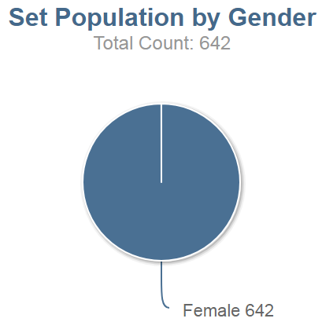
Figure 1. Estimated ovarian/uterine cancer cases by gender (based on ICD-9 diagnosis codes only).
As shown Figure 2, the age distribution is predominantly older, as expected, and most cases are Caucasian.
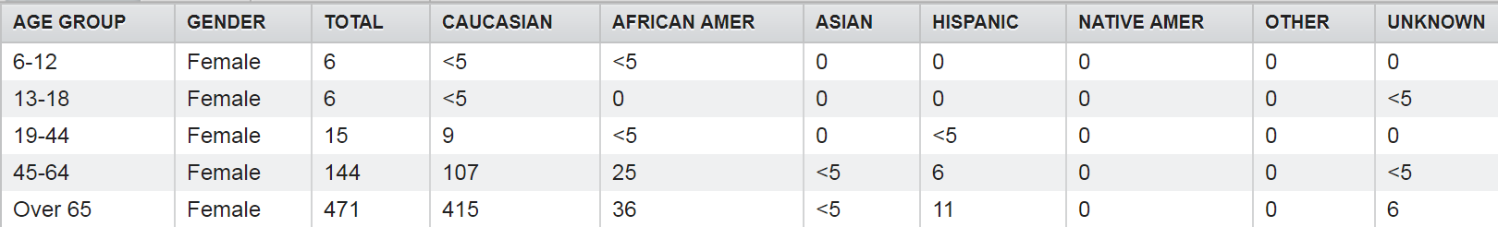Figure 2. Age and race distribution of estimated ovarian/uterine cancer cases (based on ICD-9 diagnosis codes only).
Counts of estimated ovarian/uterine cancer cases by site are shown in Figure 3. These estimates are expected to be conservative. At this phenotype’s primary development site, KPW/UW, the estimated number of cases shown in Figure 3 is 79 while the actual number of cases identified by applying the complete phenotype definition is 90. Similarly, at the secondary phenotype development site, Mayo Clinic, the estimated number of cases in Figure 3 is 68 while the actual number of cases applying the complete phenotype definition is 83.
The relatively small number of estimated cases at Columbia (12), may be influenced by the fact that the estimates are based on ICD-9 codes only.
Both eMERGE pediatric (Boston Children’s and CHOP) have very few estimated cases, as is expected.
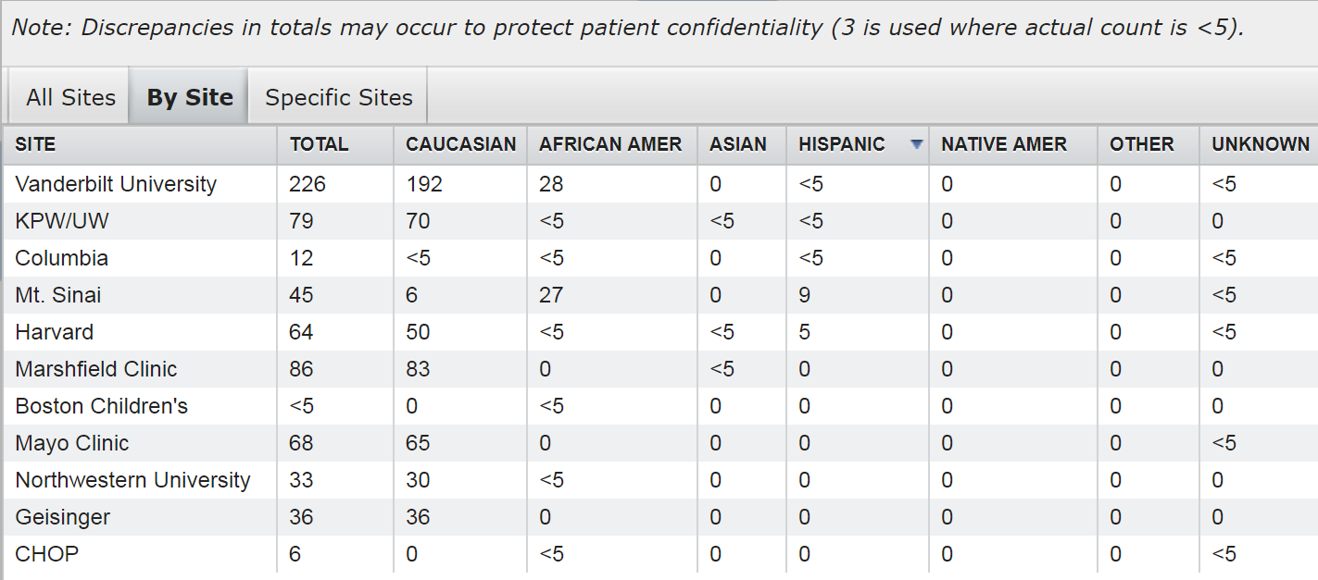
Figure 3. Counts of estimated ovarian/uterine cancer cases by eMERGE study site (based on ICD-9 diagnosis codes only).

