Extraction of patient-centered outcome for prostate cancer patients – Urinary Incontinence
Phenotype Algorithm Pseudo Code

Overview
Description of a weakly supervised machine learning approach for extracting treatment-related side effects (Urinary Incontinence) following prostate cancer therapy from multiple types of free-text clinical narratives, including progress notes, discharge summaries, history and physical notes. Prostatectomy surgery and radiation therapy are our treatments of interest for prostate cancer.
Cohort generation
The cohort is defined with the following criteria:
- EHR of all male patients of 35 years of age or more, AND
- For which there is an ICD-9-CM / ICD-10-CM diagnosis of prostate cancer, AND
- For which there are at least two encounters before first treatment, AND
- For which there is at least one clinical notes before first treatment, AND
- For which there is either prostatectomy surgery or radiation procedure performed as identified by CPT codes.

Common terminology used for UI description
incontinence
incontinent
weak incontinence
incontinence of urine
leakage
any leaks
any leak
significant problems with lower urinary tract symptoms
significant lower urinary tract symptoms
significant problems with urinary tract symptoms
lower urinary tract symptom
lower urinary tract symptoms

The whole vocabulary learnt can be found here -
Urinary_Incontinence
incontinence
incontinent
weak incontinence
incontinence of urine
leakage
any leaks
any leak
significant problems with lower urinary tract symptoms
significant lower urinary tract symptoms
significant problems with urinary tract symptoms
lower urinary tract symptom
lower urinary tract symptoms
urinary tract symptoms
any voiding issues
urine leak
urinary leakage
urine leaking
urine leakage
urinary incontinence
urinary and fecal incontinence
urinary or fecal incontinence
urge incontinence
stress incontinence
stress urine incontinence
urinary stress incontinence
stress urinary incontinence
stress or urge incontinence
urge or stress incontinence
involuntary urination
unable to hold urine
unable to control bladder
bladder control
bladder incontinence
unable to prevent bladder emptying
loss of bladder control
significant lower urinary tract symptoms
loss of urinary control
pads
pad
diapers
diaper
wears diaper
wear diapers
wears a diaper
wears a pad
wear a diaper
wears diapers
post micturition dribbling
post-micturition dribbling
post void dribbling
post-void dribbling
post-void leakage
post void leakage
postvoid dribbling
dribbles postvoid
dribbles post-void
post-void dribble
post-void dribbles
postvoid dribble
postvoid dribbles
Incontinence: 0

Characterization
We classify each note as:
(1) Affirmed: symptom present;
(2) Negated: symptom negated;
(3) Discussed Risk: clinician documented a discussion regarding risk of the symptom.
(4) Not discussed – no information present regarding the symtom
Algorithm
We extract urinary incontinence (UI) status from a range of clinical notes without considering manually engineered classification rules or large-scale manual annotations. For learning, the method exploits two sources of pre-existing medical knowledge: (1) domain-specific dictionaries that have been previously developed for implementing a rule-based information extraction system; and (2) publicly available CLEVER terminology that represents a vocabulary of terms that often present within clinical narratives. We extracted the UI status before (baseline) and after the treatment (3months, 6months, 12months and 24 months) at different time points based of date of encounters of the clinical notes.
Flow diagram
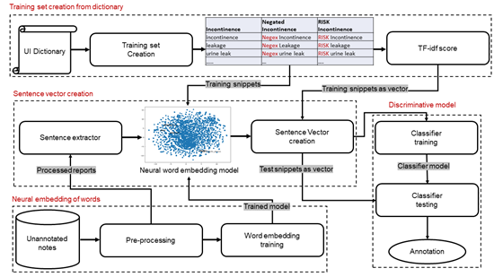
- A weighted neural word embedding is used to generate sentence-level vectors where term weights are computed using term frequency and inverse document frequency (TF-idf) scoring mechanism, with sentence labels derived from a mapping against domain-specific dictionaries combined with CLEVER (weak supervision).
- These sentence vectors are used to train a machine learning model to determine whether UI were affirmed or negated, and whether the clinician discussed risk with the patient.
- Finally, we combine the sentence-level annotations using majority voting to assign a unique liable for the entire clinical note.
Github code
Our code base can be clone from here (git@github.com:imonban/UI_Incontinence.git) which takes a csv file as input with mandatory fields (case- sensitive): 'PAT_DEID', 'NOTE_DEID', 'NOTE', 'NOTE_DATE', and outputs a csv file with note level annotations.

