Human Immunodeficiency Virus (HIV)
Phenotyping Algorithm Pseudocode

BACKGROUND
Human Immunodeficiency Virus (HIV) is a retrovirus that attacks the immune system, specifically CD4+ T-cells. If left untreated, infection causes patients to become severely immunocompromised culminating in Stage 3 infection or Acquired Immunodeficiency Syndrome (AIDS). With the development of HIV-specific antiretroviral medications, HIV infection has transformed from a terminal illness to a chronic condition, and with treatment, people with HIV have life expectancies that mirror their non-infected counterparts. Consistent access and adherence to treatment is necessary for people with HIV to remain healthy and to reduce transmission to others. For more information, see cdc.gov/hiv/basics/whatishiv.html.

ALGORITHM DATA ELEMENTS
This algorithm requires the following data elements:
- Patient age
- Laboratory test results
  - HIV confirmatory test results
  - HIV viral load measurement test results
- HIV-specific antiretroviral medications
Listings of laboratory tests derived from our datasets and medications required for the algorithm can be found in the appendices at the end of this document.

CASES
People with HIV (cases) are identified by first applying the inclusion criteria and then excluding patients who meet any of the exclusion criteria.
Case Inclusion Criteria:
Potential cases must meet any one of the following inclusion criteria:
- Has ever had a positive result on an HIV confirmatory test (see Appendix A)
- Has ever had an HIV viral load measurement (Appendix B) greater than 1000 copies/mL
- Has ever been prescribed an antiretroviral medication used to treat HIV infection (Appendix C)
Case Exclusion Criteria:
Patients are excluded from the cohort of potential cases if they meet any of the following criteria:
- Under 13 years of age at the time of assessment
- Has been prescribed any antiretroviral medication used for HIV pre-exposure prophylaxis (PrEP) or to treat Hepatitis B (HBV) infection (Appendix D) and meets all of the following criteria
    - Absence of a prescription for other HIV-specific antiretroviral medications listed in Appendix C
    - Does not meet inclusion criteria I.1 and I.2

CONTROLS
Controls are identified by applying the control inclusion criteria and then excluding patients who meet any of the control exclusion criteria.
Control Inclusion Criteria:
Potential controls must meet any one of the following criteria:
- Does not meet any of the case inclusion criteria
- Excluded from the case cohort due to case exclusion criteria E.2
Control Exclusion Criteria:
Patients are excluded from the cohort of potential controls if they meet any of the following criteria:
- Under 13 years of age at the time of assessment

FLOW DIAGRAM
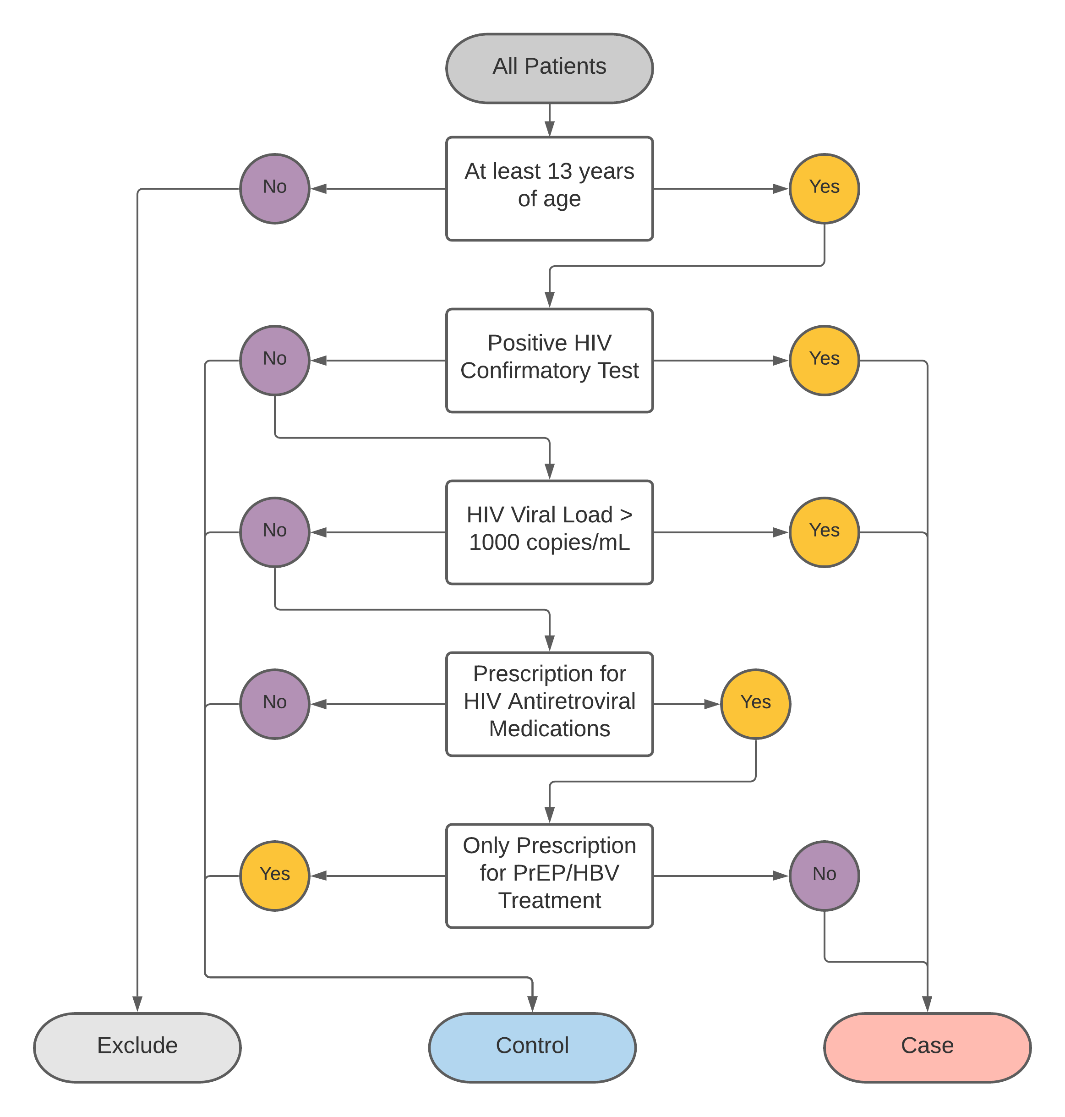

Appendix A
HIV Confirmatory Lab Tests
To make a diagnosis of HIV infection, a patient who tests positive on an HIV screening test must subsequently test positive on and HIV confirmatory test (CDC screening guidelines: http://dx.doi.org/10.15620/cdc.23447). These confirmatory tests include Western blot, immunofluorescence assays, and HIV-1/2 differentiation assays. Table 1 provides a list of LOINC codes and associated names of HIV confirmatory tests.
Table 1: HIV Confirmatory Tests
LOINC Code | Lab Procedure Name
14092-1 | HIV 1 Ab [Presence] in Serum by Immunofluorescence
5221-7 | HIV 1 Ab [Presence] in Serum or Plasma by Immunoblot
33806-1 | HIV 2 IgG Ab [Presence] in Serum by Immunoblot
5225-8 | HIV 2 Ab [Presence] in Serum by Immunoblot
44873-8 | HIV 1+2 Ab [Presence] in Serum by Immunoblot
13499-9 | HIV 1 Ab band pattern [Interpretation] in Serum by Immunoblot
69668-2 | HIV 1 and 2 Ab [Identifier] in Serum or Plasma by Rapid immunoassay
40732-0 | HIV 1 IgG Ab [Presence] in Serum by Immunoblot

Appendix B
HIV Viral Load Laboratory Tests
Table 2 provides a list of LOINC codes and associated names of HIV viral load laboratory tests.
Table 2: HIV Viral Load Tests
LOINC Code | Lab Procedure Name
10351-5 | HIV 1 RNA [Units/volume] (viral load) in Serum or Plasma by Probe with amplification
23876-6 | HIV 1 RNA [Units/volume] (viral load) in Plasma by Probe with signal amplification
20447-9 | HIV 1 RNA [#/volume] (viral load) in Serum or Plasma by NAA with probe detection
49890-7 | HIV 1 RNA [Log #/volume] (viral load) in Unspecified specimen by NAA with probe detection
29539-4 | HIV 1 RNA [Log #/volume] (viral load) in Plasma by Probe with signal amplification
25836-8 | HIV 1 RNA [#/volume] (viral load) in Unspecified specimen by NAA with probe detection
5018-7 | HIV 1 RNA [Presence] in Unspecified specimen by NAA with probe detection
70241-5 | HIV 1 RNA [#/volume] (viral load) in Plasma by Probe and target amplification method detection limit = 20 copies/mL
29541-0 | HIV 1 RNA [Log #/volume] (viral load) in Serum or Plasma by NAA with probe detection
20447-9 | HIV 1 RNA [#/volume] (viral load) in Serum or Plasma by NAA with probe detection
24013-5 | HIV 1 RNA [Interpretation] in Serum
44871-2 | HIV 1 proviral DNA [Presence] in Blood by NAA with probe detection
41498-7 | HIV 1 RNA [#/volume] (viral load) in Cerebral spinal fluid by NAA with probe detection
48551-6 | HIV 1 RNA [#/volume] (viral load) in Serum or Plasma by Probe and target amplification method detection limit = 400 copies/mL
48511-0 | HIV 1 RNA [#/volume] (viral load) in Serum or Plasma by Probe and target amplification method detection limit = 50 copies/mL
41497-9 | HIV 1 RNA [Log #/volume] (viral load) in Cerebral spinal fluid by NAA with probe detection
51780-5 | HIV 1 RNA [Log #/volume] (viral load) in Serum or Plasma by Probe and target amplification method detection limit = 0.5 log copies/mL
48510-2 | HIV 1 RNA [Log #/volume] (viral load) in Serum or Plasma by Probe and target amplification method detection limit = 1.7 log copies/mL
48552-4 | HIV 1 RNA [Log #/volume] (viral load) in Serum or Plasma by Probe and target amplification method detection limit = 2.6 log copies/mL
62469-2 | HIV 1 RNA [Units/volume] (viral load) in Serum or Plasma by NAA with probe detection
5017-9 | HIV 1 RNA [Presence] in Blood by NAA with probe detection
50624-6 | HIV 1 RNA panel (viral load) in Cerebral spinal fluid by NAA with probe detection
73658-7 | HIV 1 subtype in Unspecified specimen by NAA with probe detection
53825-6 | HIV 1+Hepatitis C virus RNA [Presence] in Serum or Plasma by NAA probe detection
59052-1 | HIV 1+Hepatitis C virus RNA+Hepatitis B virus DNA [Presence] in Serum or Plasma by NAA with probe detection
25841-8 | HIV 2 proviral DNA [Presence] in Blood by NAA with probe detection
25842-6 | HIV 2 proviral DNA [Presence] in Unspecified specimen by NAA with probe detection
69354-9 | HIV 2 RNA [Units/volume] (viral load) in Serum or Plasma by NAA with probe detection
69353-1 | HIV 2 RNA [Presence] in Serum or Plasma by NAA with probe detection
73659-5 | HIV 2 subtype in Unspecified specimen by NAA with probe detection
41516-6 | HIV 1 RNA [Log #/volume] (viral load) in Serum or Plasma by Probe with amplification detection limit = 1.9 log copies/mL
41514-1 | HIV 1 RNA [Log #/volume] (viral load) in Serum or Plasma by Probe with amplification detection limit = 2.6 log copies/mL
47359-5 | HIV 1 RNA [Presence] in Serum or Plasma from Donor by Probe with amplification
59419-2 | HIV 1 RNA [#/volume] (viral load) in Plasma by Probe with signal amplification
21008-8 | HIV 1 RNA [#/volume] (viral load) in Serum or Plasma by Probe
41513-3 | HIV 1 RNA [#/volume] (viral load) in Serum or Plasma by Probe with amplification detection limit = 400 copies/mL
41515-8 | HIV 1 RNA [#/volume] (viral load) in Serum or Plasma by Probe with amplification detection limit = 75 copies/mL
77369-7 | HIV 1 RNA [Presence] in Semen by NAA with probe detection
81246-1 | HIV 2 RNA panel – Serum or Plasma by NAA with probe detection
81652-0 | HIV 2 RNA [Log #/volume] (viral load) in Serum or Plasma by NAA with probe detection
85361-4 | HIV 1+2 RNA [Presence] in Blood by NAA with probe detection
85368-9 | HIV 1+2 RNA [Presence] in Serum or Plasma by NAA with probe detection
86547-7 | HIV 2 RNA [#/volume] (viral load) in Cerebral spinal fluid by NAA with probe detection
86548-5 | HIV 2 RNA [#/volume] (viral load) in Plasma by NAA with probe detection
86549-3 | HIV 2 RNA [Log #/volume] (viral load) in Cerebral spinal fluid by NAA with probe detection
25835-0 | HIV 1 RNA [Presence] in Serum or Plasma by NAA with probe detection

Appendix C
Antiretroviral Medications Used for HIV Treatment
Table 3 provides a list of generic and brand names for the antiretroviral medications used for the treatment of HIV.
Table 3: Antiretroviral Medications for HIV Treatment
Generic Name (Abbreviation) | Brand Name
Emtricitabine (FTC) | Emtriva
Lamivudine (3TC) | Epivir
Zalcitabine, dideoxycytidine (ddC) | Hivid
Zidovudine, azidothymidine (AZT, ZDV) | Retrovir
Didanosine, dideoxyinosine (ddI) | Videx
Tenofovir disoproxil fumarate (TDF) | Viread
Stavudine (d4T) | Zerit
Abacavir sulfate (ABC) | Ziagen
Rilpivirine | Edurant
Etravirine | Intelence
Delaviridine (DLV) | Rescriptor
Efavirenz (EFV) | Sustiva
Nevirapine (NVP) | Viramune
Amprenavir (APV) | Agenerase
Tipranavir (TPV) | Aptivus
Indinavir (IDV) | Crixivan
Saquinavir | Fortovase
Saquinavir mesylate (SQV) | Invirase
Fosamprenavir calcium (FOS-APV) | Lexiva
Ritonavir (RTV) | Norvir
Darunavir | Prezista
Atazanavir sulfate (ATV) | Reyataz
Nelfinavir mesylate (NFV) | Viracept
Enfuvirtide (T-20) | Fuzeon
Maraviroc | Selzentry
Raltegravir | Isentress
Dolutegravir | Tivicay
Elvitegravir | Vitekta
Cobicistat | Tybost
Efavirenz/emtricitabine/tenofovir disoproxil fumarate | Atripla
Emtricitabine/rilpivirine/tenofovir disoproxil fumarate | Complera
Atazanavir/cobicistat | Evotaz
Cobicistat/darunavir ethanolate | Prezcobix
Elvitegravir/cobicistat/emtricitabine/tenofovir disoproxil fumarate | Stribild
Lamivudine/zidovudine | Combivir
Abacavir/lamivudine | Epzicom
Abacavir/zidovudine/lamivudine | Trizivir
Tenofovir disoproxil fumarate/emtricitabine | Truvada
Lopinavir/ritonavir | Kaletra
Tenofovir alafenamide/emtricitabine | Descovy
Rilpivirine/tenofovir disoproxil fumarate/emtricitabine | Odefsey
Elvitegravir/cobicistat/tenofovir alafenamide/emtricitabine | Genvoya
Dolutegravir/abacavir/lamivudine | Triumeq

Appendix D
Medications for HIV Pre-exposure prophylaxis (PrEP) and Hepatitis B (HBV) Infection
Some antiretroviral medications used to treat HIV can also be prescribed for HIV prevention (PrEP) or to treat HBV infection. Patients prescribed any of the medications listed in Table 4, in the absence of prescriptions for any of the HIV-specific antiretrovirals listed in Appendix C, and in the absence of a positive HIV confirmatory test and a positive HIV viral load (Appendix A and B), should be excluded from the cohort of people living with HIV.
Table 4: Antiretrovirals used for PrEP and/or HBV treatment
Indication | Generic Name (Abbreviation) | Brand Name
PrEP/HBV | Emtricitabine (FTC) | Emtriva
HBV | Lamivudine (3TC) | Epivir
PrEP/HBV | Tenofovir disoproxil fumarate (TDF) | Viread
PrEP/HBV | Tenofovir disoproxil fumarate/emtricitabine | Truvada
PrEP | Tenofovir alafenamide/emtricitabine | Descovy

